CURRICULUMN VITAE

Leon Glikman (Estonian I.D. 35705240218). |  |  |  | 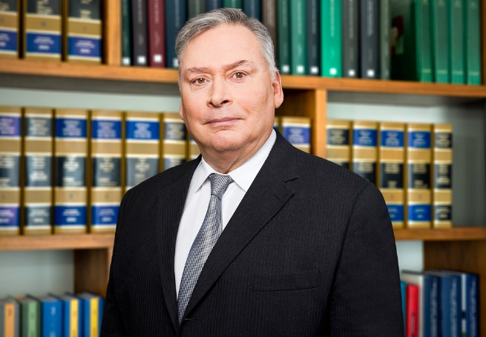
 | Date of birth: May 24, 1957
 | Occupation (currently or/and formerly): Attorney at Law (Sworn Advocate), Partner. Head of arbitration, mediation and litigation team.
 | Courier address: Maakri 45 Tallinn 10145 Estonia
 | Cell phone No.: +3725016310  Phone: + 3726860000 |  | Fasimile:
 | Email: leon.glikman@levinlaw.ee
 | Professional specialty: arbitration,mediation,litigation
 | Language skills: Fluent - English, Estonian, Russian. Communication level - Finnish and Spanish
Education
Qualifications |  | Law
Major(s) |  | Arbitration, litigation, mediation
University(s) |  | Harvard Law School (LL.M); courses in the law schools of Columbia University and Georgetown University; Internship in the US Bar Association; Faculty of Law of the University of Tartu, M.A (5 year program).
Work history
Time 2004 - present |  | Law Firm Glikman Alvin Levin. Partner, Attorney at Law (Sworn Advocate).
Time 1991-2004 |  | Law Firm Glikman & Glikman. Partner, Attorney at Law.
Time1993-1995 |  | Law Firm McDermott, Will & Emery (U.S.A.). Director, Attorney at Law.
Time1992  1981-1991 |  | Law Firm Miller Canfield Paddock & Stone (U.S.A.). Of counsel, intern.  Law Firm No. 1. Attorney at Law
Membership and Activities
2017 - present |  | Conciliator of the International Centre for Settlement of Investment Disputes (ICSID)
2018 - present |  | Member of the ICC International Court of Arbitration
2018 - present |  | Recommended arbitrator of the permanent Arbitration Institution of the Russian Arbitration Association
2015 - present |  | Member of the Fundamental Rights Committee of the Estonian Bar Association
2000 -present |  | Member of the Court of Honour of the Estonian Bar Association
2002- present |  | Israel’s Honorary Consul in Estonia
1981 - present |  | Member of the Estonian Bar Association
1981 - present |  | Practices law with a focus on arbitration, mediation and litigation from 1981.  Has served as an arbitrator or mediator in arbitration courts of  Estonian Chamber of Commerce; the Arbitration Institute Stockholm Chamber of Commerce; the Arbitration Institute of Finland Chamber of Commerce, etc.
1994- present |  | Legal tutoring.
1994- present |  | Has published over 100 articles regarding law, economy and politics.
Ranking in Chambers and Legal 500 |  | Hall of fame, exquisite

